Supplementary Information for

**A predicted CRISPR-mediated symbiosis between uncultivated archaea**

**Content**:

1. Supplementary Results
2. Supplementary Figures
3. List of Supplementary Tables and Data
4. References
5. **Supplementary Results**

**Analysis of Altiarchaea-viral interactions reveal new viral clades in the CG ecosystem**

In total, 64 predicted vOTUs (vOTU_CG_1 – vOTU_CG_64) were extracted and compared to previously published altiarchaeal vOTUs Altivir_1 - Altivir_8 from different ecosystems1 (Fig S5). Many of the singletons and outliers as determined by vConTACT2 were identified to be of viral origin using CheckV2 (Table S6). In total 41 fragments were assigned as viral, one as partly viral and host, and 17 as complete host fragment. The five residual sequences remained unassigned. The completeness of the extracted viral sequences varied between 2% and 56.1%, according to CheckV and under consideration of the most adequate method for completeness determination (AAI-based or HMM-based, Table S6). This underlines how fragmented these vOTUs are. The GC content and coding densities on vOTUs ranged between 18.7-65.1% (median=34.3%) and 51.1-98.7% (median=92.9%), respectively (Table S6). All vOTUs were classified as lytic viruses being affiliated to VirSorter3 category 1-3, supporting previous evidence for a predominance of lytic infections of *Ca.* Altiarchaea in subsurface ecosystems1.

Both VICTOR and vConTACT2 v.0.11.3 resulted in 14 VCs, each of them corresponding to an individual genus. Both tools revealed 40 and 42 new viral clades (including unclustered singletons and outliers, which likely represent new viruses), respectively. Many VCs were further supported using VIRIDIC and therein a genus and species threshold of 70% and 95% (Extended Data Fig. 2), respectively. Here, we detected 11 genus-based VCs with two of them also forming species clusters based on intergenomic comparisons (Extended Data Fig. 2). Including unclustered singletons, VIRIDIC revealed 46 new viral clades, and all tools showed profound overlap for VC detection (Table S6). However, it should be noted that all viruses from all metagenomes were dereplicated at 95% nucleotide identity to reduce the dataset. Clustering of *Ca.* Altiarchaea associated vOTUs, determined by spacer-protospacer matches against vOTUs from VirSorter, with a recent database (release July 2022) revealed no clustering with any previously known virus from the database or previously described *Ca.* Altiarchaea viruses1 at the genus level. Despite not being related at the genus level, some of the vOTUs share protein clusters with known bacteriophages of different VCs (Figure S5, Table S6). Three of the vOTUs vOTU_CG_11, vOTU_CG_44, and vOTU_CG_51, were targeted by one, 350 and 295 spacers from transcriptomic data (samples CG05, CG08, and CG16), respectively. These matching spacers from the transcriptomes indicate active acquisition of spacers from these viruses. By constructing a proteomic tree (Fig. S6) together with RefSeq database viruses, several vOTUs with infection histories with *Ca.* Altiarchaea clustered with phages of the host group Pseudomonadota, Actinomycetota and Bacillota, but also viruses from Chordata and “other” hosts, while “others” included different archaeal hosts such as Thermoproteus, Pyrobaculum, Pyrococcus, or Thermococcus. The tree thus indicates that CRISPR spacer acquisition by Ca. Altiarchaea from vOTUs might occur from phylogenetically distant viruses, a phenomenon that has been observed for other ecosystems4.

**Protospacer regions in host and episymbiont are associated with drops in scaffold coverage**

A total of 17% of the protospacer regions (34 out of 196) of the CRISPR-Cas type I-B system that represent targeted genomic regions of the host (*Ca.* A. crystalense) showed significant decreases in metagenomic coverage compared to untargeted regions of the very same scaffold, which we determined using a sliding window algorithm (see Supplementary Methods) paired with a bootstrapped Wilcoxon paired signed rank test. A significance level of 5% (p < 0.05) was tested for each protospacer region and the p-values were FDR-adjusted.

A total of 30% of the protospacers (22 out of 73) of the CRISPR-Cas type I-B system that represent targeted genomic regions of the episymbiont (in *Ca.* H. crystalense) showed significant decreases in metagenomic coverage compared to untargeted regions of the very same scaffold, which we determined using a sliding window algorithm (see Supplementary Methods) paired with a bootstrapped Wilcoxon paired signed rank test. A significance level of 5% (p < 0.05) was tested for each protospacer region and the p-values were FDR-adjusted.

The coverage of the targeted regions, compared to the average coverage of the scaffold decreases in *Ca.* A. crystalense and *Ca.* H. crystalense by 30.13% (mean ± STD, STD=40.79%) and 32.3% (mean ±37.32%), respectively (bootstrapped Wilcoxon signed rank test, n=1000, where for n=990 FDR-corrected p-values were < 0.05, for median please see main manuscript). In other words, 17% of the self-targeted host regions showed a drop of 30.13% in coverage, while in 30% of the episymbiont-target sites the coverage of the scaffold dropped by 32.3%. The high variation of coverage was expected as scaffold coverage was determined for a microbial population (rather than a discrete species) across multiple environmental samples with varying microbial composition5. Overview of the most important percent values are presented in Table S5.

**Complementary metabolism between *Ca.* Altiarchaea or *Ca.* Huberiarchaea**

In the CG system, 32 metabolites were predicted to be transferred from *Ca.* A. crystalense to *Ca.* H. crystalense under minimum interactions between these two to produce non-zero biomass for both, including glucose, ATP, amino acids (all except for Asn, Cys, Phe, Tyr), reducing equivalents (i.e. NADH and reduced ferredoxin), formate, chorismate (precursor of aromatic amino acids biosynthesis), and vitamins (Table S10). Eight metabolites were predicted to be transferred from *Ca.* H. cystalense to *Ca.* A. crystalense (Fig. S8 A-C), including malate, oxidized compounds, and dUMP, which is the product of a dCMP deaminase reaction in *Ca.* H. crystalense that is required for completing the pyrimidine biosynthesis in *Ca.* A. crystalense (Fig. S8 C). Similarly, in the HURL system, 24 metabolites were predicted to be transferred from *Ca.* A. horonobense to *Ca.* H. julieae, including glucose, ATP, amino acids (all except for Asp, Asn, Cys, Phe, Tyr), formate, chorismate, dTMP, UTP, and vitamins. Seven metabolites were predicted to be transferred from *Ca.* H. julieae to *Ca.* A. horonobense, including 5,10-Methylenetetrahydrofolate (MLTHF), which is the product of a dTMP synthase function in *Ca*. H. julieae required for completing the folate biosynthesis pathway in *Ca.* A. horonobense (Fig. S8 D).

It is worth noting that certain functions in *Ca.* Huberiarchaea formed complementary pathways for the biosynthesis of essential biomass components in both the CG as well as in the HURL system. In the CG system, metabolic cooperation was observed in pyrimidine biosynthesis. A dUTPase (EC 3.6.1.23) was missing in *Ca.* A. crystalense, which blocks the biosynthesis of dUMP from dUTP, a pathway encoded in *Ca.* A. horonobense. As a result, the biosynthesis of dUMP in *Ca.* A. crystalense relied on a dCMP deaminase (EC 3.5.4.12), which was present in *Ca.* H. crystalense but absent in other *Ca.* Altiarchaea or *Ca.* Huberiarchaea strains examined in this study. The biosynthesis of dCMP, a substrate for the dCMP deaminase, was absent in *Ca.* H. crystalense. Therefore, *Ca.* A. crystalense was responsible for dCMP biosynthesis via a dCMP kinase (EC 2.7.4.25), while the dCMP deaminase in *Ca.* H. crystalense was responsible for bridging the dCMP biosynthesis with the production of dTTP (Fig. S8 C). Interestingly, although the collaboration of pyrimidine biosynthesis was essential for AltiCG-HuberCG, alternative metabolites could be transferred between *Ca.* A. crystalense and *Ca.* H. crystalense due to the presence of redundant pathways (represented as dotted lines in Fig. S8), which contributed to the robustness of the predicted metabolic collaboration.

In the HURL system, metabolic cooperation was observed in folate biosynthesis. This was mediated by a dTMP synthase (EC 2.1.1.45) function, which was also linked to pyrimidine biosynthesis (Fig. S8 D). The dTMP synthase in *Ca*. H. julieae bridged a missing link in the tetrahydrofolate (THF) biosynthesis pathway of the *Ca.* A. horonobense by converting dihydrofolate (DHF) to 5,10-Methylenetetrahydrofolate (MLTHF). As a byproduct, the dTMP synthase in *Ca*. H. julieae also converted dTMP to dUMP. In collaboration with the FAD-dependent dTMP synthase (EC 2.1.1.148) in *Ca.* A. horonobense, the dTMP and dUMP were cycled while driving the biosynthesis of THF in the AltiHURL-HuberHURL system (Fig. S8 E). Interestingly, while the dTMP synthase was encoded in *Ca.* Altiarchaeum crystalense and *Ca.* H. crystalense, it was only encoded in *Ca*. H. julieae in the HURL system, indicating the observed coupling of folate biosynthesis could be unique to the HURL system.

**Single nucleotide polymorphism (SNP) prediction within PAM sequences**

Using the predicted spacer target locations and the SNP locations, SNP frequencies in vicinity of spacer targets were calculated for all positions inside the spacer targets relative to the 5’ end, as well as outside the spacer targets in a range of 2000 bases with location relative to the 5’ or 3’ end of the spacer respectively. Regression curves were calculated via locally estimated scatterplot smoothing (LOESS), as well as a fitted polynomial regression model of order three. Visualization was performed with R6,7 (version 3.6.1). Targeted genes (coverage > 8) of 9 *Ca.* A. crystalense MAGs by spacers extracted from the three samples CG05, CG08, and CG16 were used to calculate the average SNP ratio of the putative protospacer adjacent motif (PAM) sequence and the residual gene. A Spearman rank correlation test between the SNP frequency and the location relative to the spacers shows a significant negative correlation (exact values of correlation coefficient ρ and p-value, upstream (start) and downstream (end) of the spacer respectively: **CG05** end: ρ = -0.461, p-value < 2.2e-16, start: ρ = -0.564, p-value < 2.2e-16; **CG08** end: ρ = -0.148, p-value = 3.177e-11, start: ρ = -0.439, p-value < 2.2e-16; **CG16** end: ρ = -0.239, p-value < 2.2e-16, start: ρ = -0.663, p-value < 2.2e-16, for neighboring 2000 bases).

In the neighborhood of 500 bases, a significant negative correlation was found for samples CG05 and CG16 (CG05 end: ρ = -0.404, p-value < 2.2e-16, start: ρ = -0.225, p-value = 3.89e-7; CG16 end: ρ = -0.318, p-value = 3.028e-13, start: ρ = -0.174, p-value = 9.574e-5), but not for CG08, where the Spearman correlation is close to 0 and the p-value is > 0.05 (CG08 end: ρ = -0.064, p-value = 0.1558, start: ρ = 0.009, p-value = 0.8471). For the analysis of SNP frequency in the 500bp neighborhood outside of spacers, only self-targeted genes of *Ca.* A. crystalense genomes were selected. The total number of matching spacers and self-targeted genes in each sample were 154 genes and 396 spacers for CG05, 84 genes and 220 spacers for CG08, and 260 genes and 628 spacers for CG16.

In detail, the first base after the spacer matching region in the *Ca.* Altiarchaeum crystalense genome was analyzed separately for elevated SNP frequency. To test whether the mean SNP frequency at this position is higher than can be expected by chance, it is compared to randomly chosen spacer positions. In this procedure, for every spacer matching a stretch of a gene, a random position on this gene was chosen, leading to the same number of spacers and genes, as in the real samples. 100 of such randomized spacer position sets were generated for each sample and the mean SNP frequency of the first base relative to the spacer end was calculated. This analysis shows an increase in SNP frequency ranging from 22% to 69%, at the first base after real spacers compared to random draws. Utilizing the normal distribution of means, as indicated by the central limit theorem, a one-sided Z-test was chosen. The results show that the increase is statistically significant (Z-test) for samples CG08 (55% increase, p-value = 0.005) and CG16 (69% increase, p-value = 4.04e-9). Sample CG05 misses the threshold of significance with a p-value of 0.063 and a SNP frequency increase of 22% over the randomized data.

1. **Supplementary Figures**

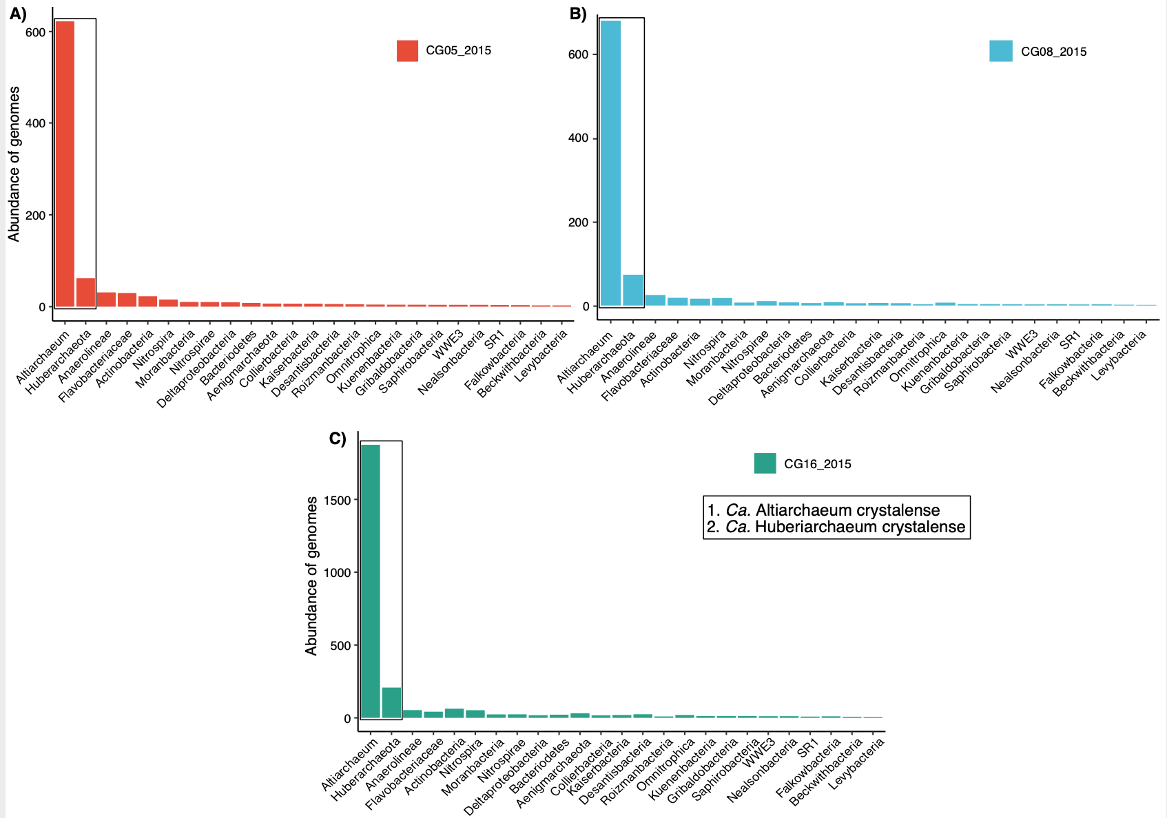

**Figure S1** | Rank abundance curves based on relative abundance of genomes in samples A) CG05, B) CG008 and C) CG16 from 20155. These three samples were selected due to the availability of corresponding transcriptomes, and because *Ca.* A. crystalenseand *Ca.* H. crystalensewere the most abundant organisms therein. Rank abundance curves are sorted based on sample CG05 for better comparability. Please note that the y-axes are differently scaled due to varying abundances of other organisms in the samples, and we only displayed organisms determined to occur in the minor eruption phase, i.e., in this subsurface ecosystem, of the Geyser (in total 25 organisms). The calculations of the rank abundances also visualize that the relative abundance ratio of *Ca.* A. crystalense and *Ca.* H. crystalense is constant over these samples, which underlines their host-symbiont relationship, and which was previously published in Schwank et al. (2018) for this ecosystem8.

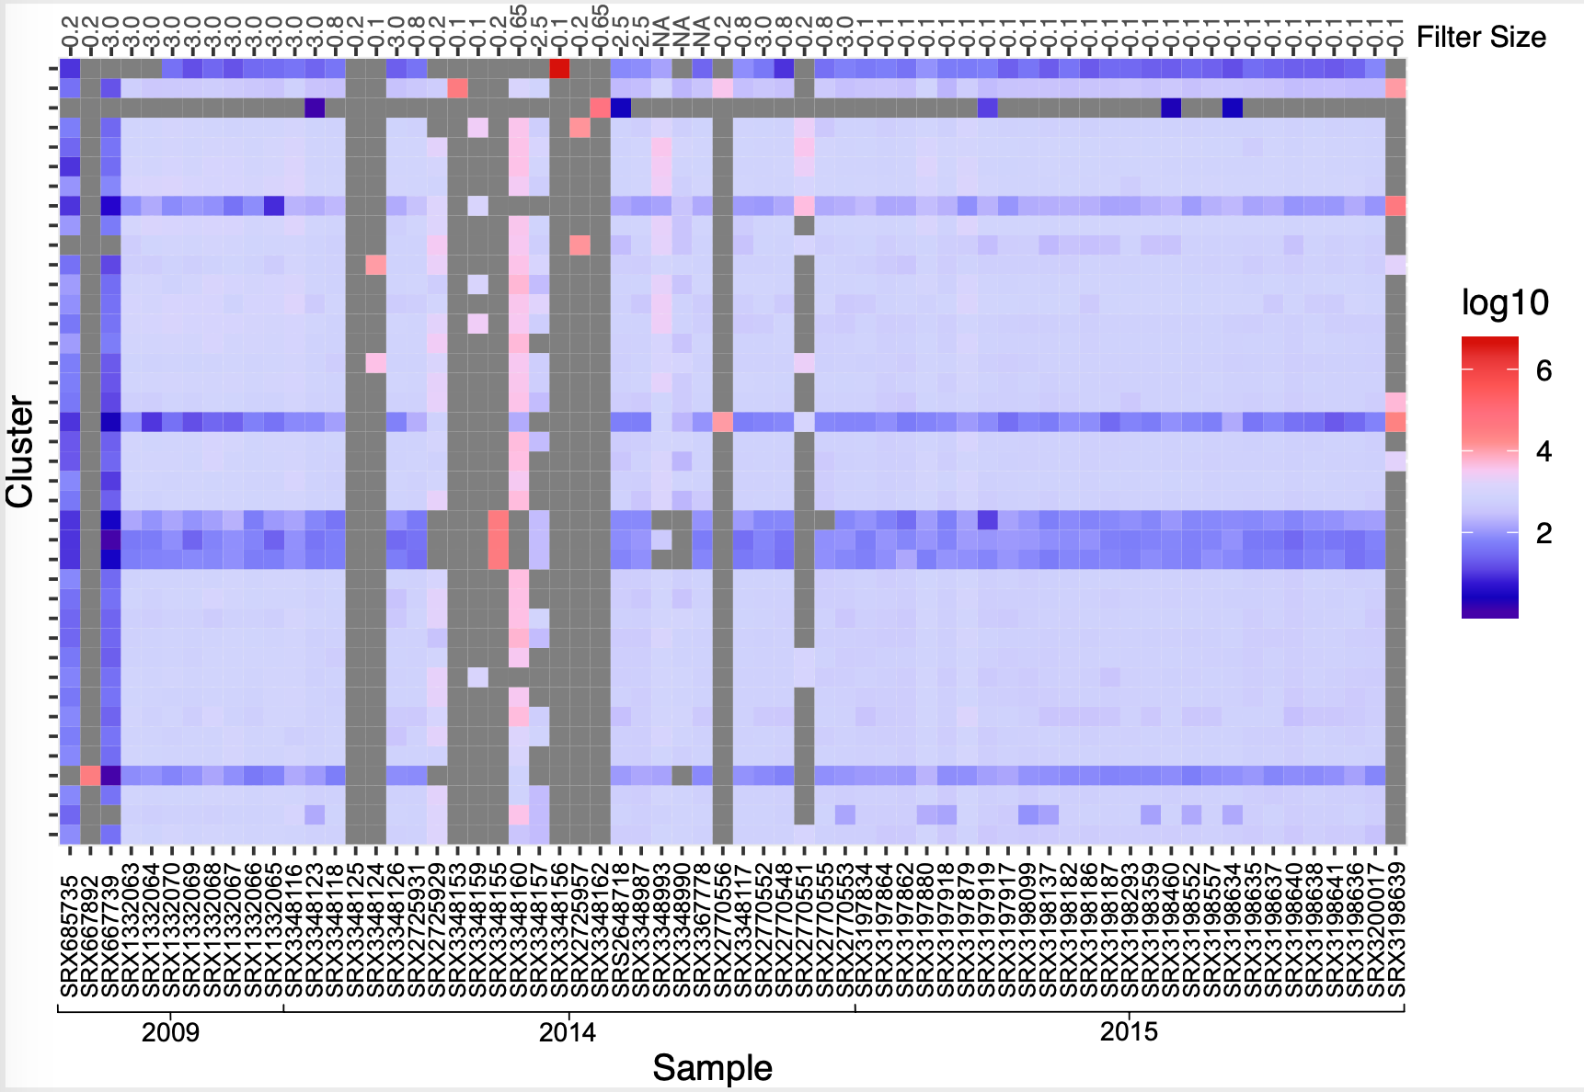

**Figure S2** | Relative abundance of spacer clusters from CRISPR system type I-B in Crystal Geyser over a time span of six years and based on 66 metagenome samples (n=66), with x-axis showing the NCBI accession number of the respective sample (Table S1). Spacer clusters are normalized on *Ca.* A. crystalense genome abundances within each sample. The 40 most abundant spacer clusters (out of 297,531 spacer clusters) are depicted. Grey color indicates absence of spacer clusters in a metagenome; please note that some samples were retrieved from sequential filtration through different pore sizes and thus *Ca.* Altiarchaea genomes were nearly absent in some samples. For sample details, please refer to Table S1. Visualization was performed with R6,7 (version 3.6.1).

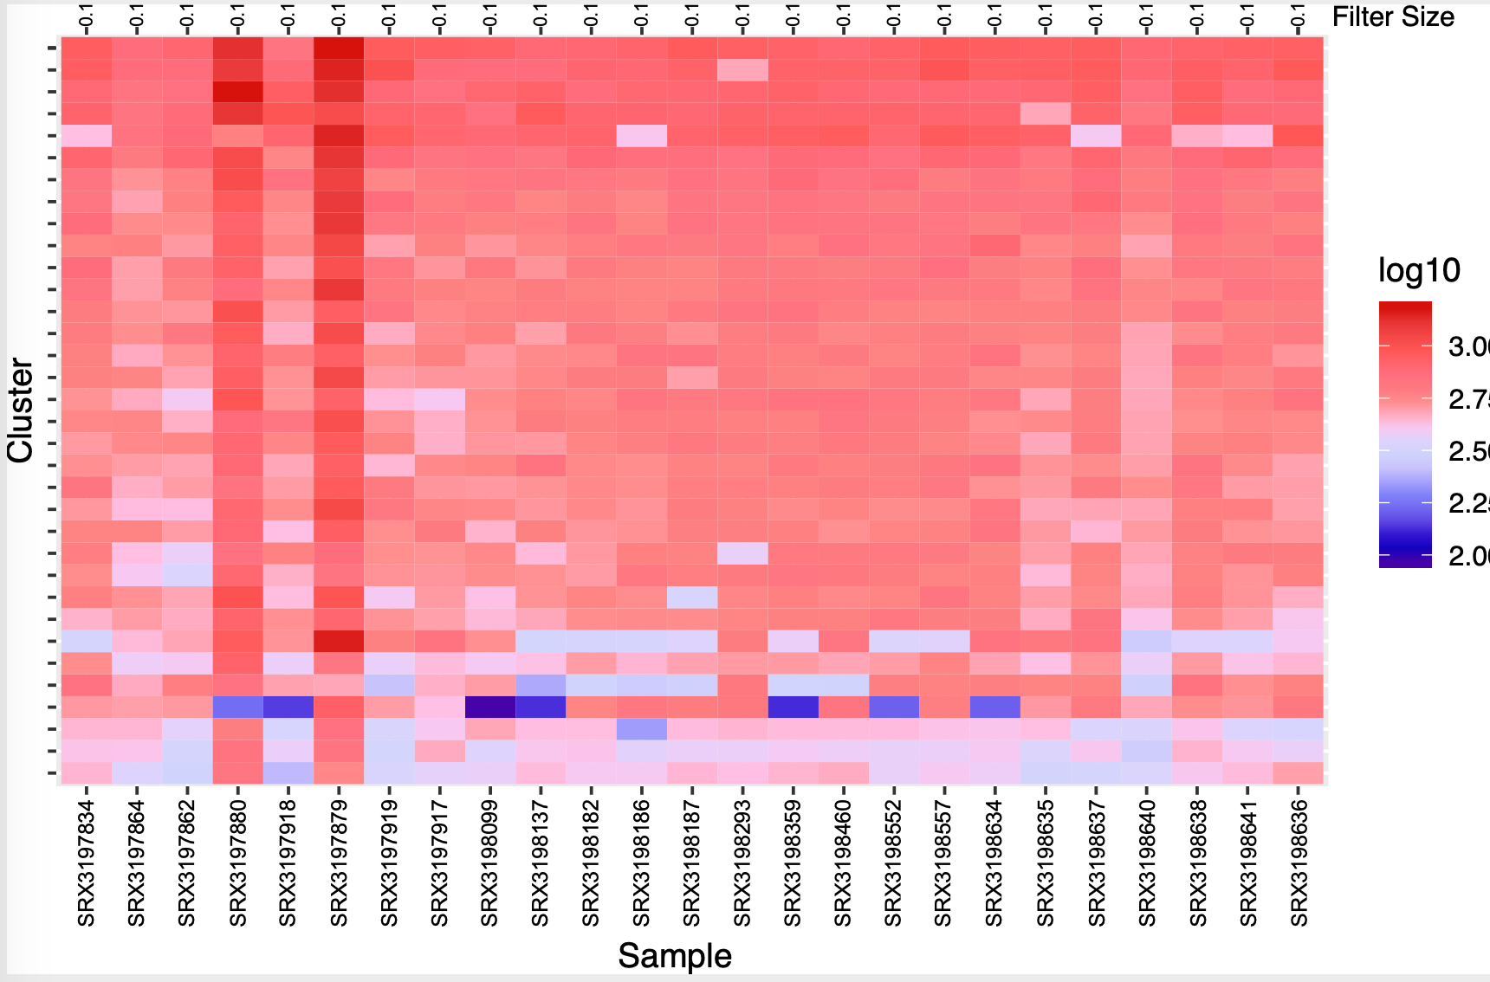

**Figure S3** | Relative abundance of spacer clusters from CRISPR system type I-B in Crystal Geyser over one eruption phase in 2015 (n=25), with x-axis showing the NCBI accession number of the respective sample (Table S1). Spacer clusters are sorted in order of sampling. All PCR amplified metagenomic datasets are excluded5. Spacer clusters are normalized on *Ca.* A. crystalense genome abundances within each sample. The 34 most abundant spacer clusters (out of 297,531 spacer clusters) are depicted. For sample details, please refer to Table S1. Visualization was performed with R6,7 (version 3.6.1).



**Figure S4** | Clustering of Crystal Geyser vOTUs with previously published altiarchaeal vOTUs *Altivir_1 - Altivir_8* from other subsurface ecosystems1 using VICTOR9. The Figure shows the phylogenomic GBDP10 tree inferred using the formula D0 yielding average support of 64%. OPTSIL clustering yielded 73 species clusters and 48 genus clusters including previously detected vOTUs1. The numbers above branches are GBDP pseudo-bootstrap support values from 100 replications. All identical colored viruses are at least assigned to the same genus. Viral clusters (VC) refer to clusters mentioned in Table S6. Singletons are indicated in black. VCs formed by Altivir_1_MSI and Altivir_2_MSI were described in Rahlff *et al* 20211.



**Figure S5 |** Network of *Ca.* Altiarchaeum associated vOTUs identified by spacer-protospacer matches, and forming 14 viral clusters (VCs) and their relationships with viruses from a viral Refseq database11 (release July 2022). The network shows interaction (edges) between viruses (nodes) based on shared protein clusters. Most vOTUs form genus clusters with other viruses associated to *Ca.* Altiarchaeum (pink enlarged circles) and cluster with database viruses from VC_145_2, VC_408, VC_409, VC_849. Some unclustered vOTUs (outliers in vConTACT2, grey enlarged circles) were related to viruses from different subclusters of VC_461, VC_628, or other outliers (grey diamonds) of the reference database. For further information about correspondence of VC designation with VC designations in Fig S4 & Extended Data Fig. 2 as well as members of the VCs clustering with viruses at higher rank than genus level please refer to Table S6. Data were visualized using Cytoscape v.3.9.0.12.

 **Figure S6 |** Circular viral proteomic tree designed by ViPTree 13. Positioning of vOTUs from this study is indicated by red stars in the tree.

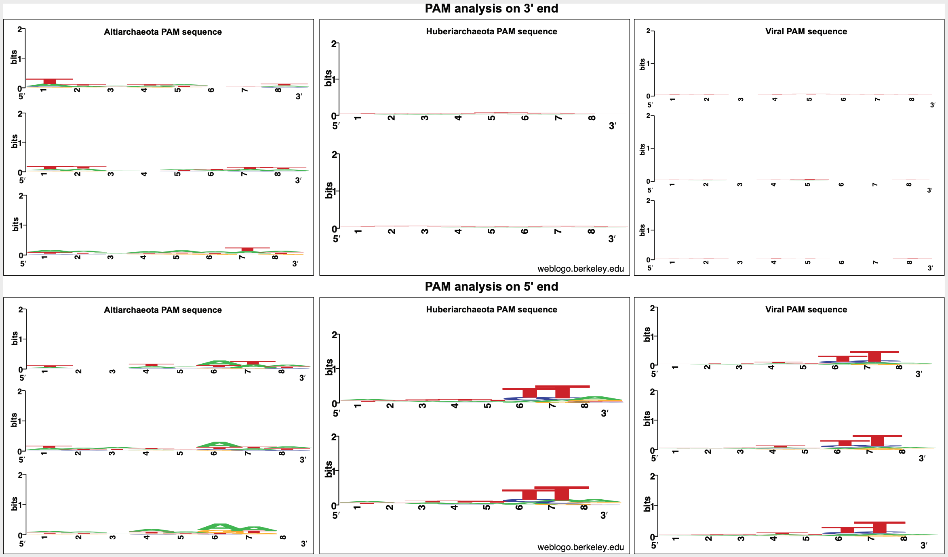

**Figure S7 |** Protospacer adjacent motifs (PAM) of *Ca.* Altiarchaea, *Ca.* Huberiarchaea and all vOTUs from CG for CRISPR system type I-B analyzed with CRISPRTarget14 (accessed in June 2020) and WebLogo15,16 (accessed in June 2020). For the analysis of PAM sequences all matching spacers with 80% similarity were used. As WebLogo has a maximal input of 10,000 spacers for one sequence design, the analysis to create a PAM sequence logo had to be split in two to three batches. We found 23,208, 14,479, and 29,044 spacer matches against 18 *Ca.* A. crystalense genomes, eleven *Ca.* H. crystalense genomes and 64 vOTUs, respectively, with a cutoff score >19 in CRISPRTarget for the identification of a PAM. A 5' consensus PAM of the sequence TTN was found for *Ca.* H. crystalense and the vOTUs, but none was detected for *Ca.* A. crystalense. Contrasting the analysis with spacers from CRISPR system type I-B, the identification of a PAM sequence for the unassigned CRISPR array resulted in no consensus motif sequence (data not shown).





**Figure S8 |** Complementary metabolic pathways between *Ca.* Altiarchaeum crystalense/horonobense and *Ca.* Huberiarchaeum crystalense/julieae during self-targeting of *Ca.* A. crystalense/horonobense. The dotted arrows symbolize exchange of metabolites between cells. Red arrows symbolize metabolic complementation between *Ca.* A. crystalense/horonobense and *Ca.* H. crystalense/julieae via exchange of metabolites. Blue arrows highlight genes/pathways in *Ca.* H. crystalense/julieae are necessarily involved in the metabolic interactions for this complementation. Depicted metabolic interactions without considering CRISPR-Cas interference within CG (**A-1 and B-1).** Red crosses indicate the potential deletion of metabolic functions due to attack of genes by self-targeting spacers within CG **(A-2, B-2, C-E)**.In HURL, the necessary interactions within the pyrimidine and folate biosynthesis are visualized **(D and E).**

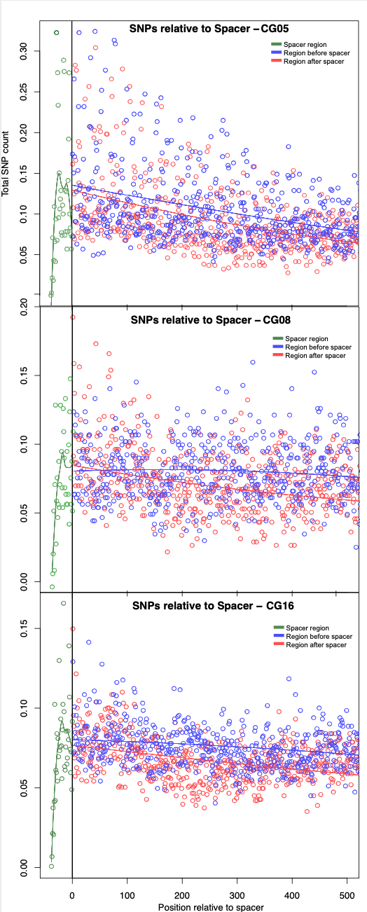

**Figure S9 |** Single nucleotide polymorphism (SNP) calling on all *Ca.* Altiarchaeum crystalense genes targeted by spacers of the CRISPR type I-B system (self-targeting). Depicted are the protospacer region (green), the bases upstream of the spacers (blue) and the bases downstream of the protospacer matching region (red). CRISPR spacer targets are oriented 3’ to 5’ with the 5’ end being adjacent to the PAM motif.

|  |  |  |
| --- | --- | --- |
| **Self-targeting of *Ca.* Altiarchaea (host)** | | |
| **CRISPR system** | **CG (percent spacer matches)** | **HURL (percent spacer matches)** |
| **Type I-B** | DNA forward: 42% vs. DNA reverse: 58% | DNA forward: 77% vs. DNA reverse: 23% |
| **Unassigned array** | DNA forward: 0% vs. DNA reverse: 100% | DNA forward: 84.5% vs. DNA reverse: 15.5% |
| **Targeting of *Ca.* Huberiarchaea (episymbiont)** | | |
| **CRISPR system** | **CG (percent spacer matches)** | **HURL (percent spacer matches)** |
| **Type I-B** | DNA forward: 44% vs. DNA reverse: 56% | N.A. |
| **Unassigned array** | N.A. | DNA forward: 88.8% vs. DNA reverse: 11.2% |

**Supplementary Table S7 | Strand-specific analysis of targets of *Ca.* Altiarchaeum-derived spacers to determine the specificity of the two CRISPR-Cas systems.** While CRISPR system type I-B is targeting the forward DNA strand in both ecosystems (for self-targeting and for targeting of the episymbiont), the unassigned CRISPR array seems to target solely the reverse strand of DNA (targeting threshold 90%) in CG and the forward strand of DNA in HURL. The analysis includes self-targeting spacers of *Ca.* Altiarchaea and spacers targeting *Ca.* Huberiarchaea genomes via matching to prodigal-predicted CDS17. In total 16 *Ca.* A. crystalense genomes, 11 *Ca.* H. crystalense genomes, and one genomes of each *Ca.* A. horonobense and *Ca.* H. julieae were used for this analysis. Please note that the number of spacers matching to the genomes are different to the numbers in the main figure 1C and 1E, because only spacers matching in the CDS regions were analyzed here. Percentages describe the proportion of spacers matching the forward strand and/or the reverse strand, respectively. N.A. = not available (no spacers/insufficient number of spacers available for analysis).

1. **List of Supplementary Tables and Data**

**These tables are provided as separate files.**

**Supplementary Table S1** | Overview of accessed metagenomes and metatranscriptomes. Accession numbers, read length, number of bases sequences, number of assembled sequences, number of extracted spacers for CRISPR system type I-B and the unassigned CRISPR array.

**Supplementary Table S2** | Accession numbers for *Ca.* Altiarchaeum crystalense/horonobense and *Ca.* Huberiarchaeum crystalense/julieae genomes.

**Supplementary Table S3** | Accession numbers and JGI IMG annotation of single amplified genomes (SAGs) from Crystal Geyser.

**Supplementary Table S4** | Accession numbers of publicly available archaeal genomes accessed May 2021.

**Supplementary Table S5** | Overview of annotated genes matched by CRISPR spacers derived from metagenomes of the samples CG05, CG08 and CG16 (Table S5.3) and of single amplified genomes. The table contains all genes of *Ca.* A. crystalense/horonobense (Table S5.1 and S5.4, respectively) and *Ca.* H. crystalense/julieae (Table S5.2 and Table S5.5, respectively) annotated with DIAMOND against the UniRef100 database and manual annotations of 101 genes matched by the spacers targeted by spacers. These datasets were used as input for genome-resolved metabolic modeling and single nucleotide polymorphism (SNP) analysis. Calculated coverage drops of targeted scaffolds in *Ca.* A. crystalense and *Ca.* H. crystalense (Table S5.6). Extended explanations of the individual data sheets are provided as content sheet in the document.

**Supplementary Table S6 |** Viral scaffolds targeting *Ca.* Altiarchaeum crystalense as determined by spacer-protospacer matches and application of different tools for virus detection1. Table shows putative origin of scaffold region (viral, host, unclassified) as determined by CheckV2, genome completeness, contig length, number of open reading frames (ORF), GC content, coding density, and viral genus and species clusters as determined using vConTACT2, VICTOR and VIRIDIC. Depending on the clustering tool used, 40 to 46 new viral clades (=sum of different viral clusters (VC), singletons, outliers) could be identified. n.d.=none determined, T indicates that viruses that were targeted by CRISPR spacers from the transcriptome, C indicates circular viral scaffolds.

**Supplementary Table S8 |** Genome-scale model of Alti-Huber metabolism in the CG system. Listed are the used basic reactions (Table S8.1) and compounds (Table S8.2) for the metabolic modeling. In addition, Table S8.3 describes the genes involved in the reactions. Unlimited interactions (Table S8.4) describes the interactions between *Ca.* Altiarchaea and *Ca.* Huberiarchaea if compounds are freely moving between the cells and the limited interactions (Table S8.5) only allows the interactions needed to result a non-zero biomass production. Table S8.6 lists the chemical compounds measured5 or assumed to calculate the metabolic model. The biomass objective functions for *Ca.* Altiarchaea and *Ca.* Huberiarchaea are listed in Table S8.7-S8.8. Extended explanations of the individual data sheets are provided as content sheet in the document.

**Supplementary Table S9 |** Genome-scale model of Alti-Huber metabolism in the HURL system. Listed are the used basic reactions (Table S9.1) and compounds (Table S9.2) for the metabolic modeling. In addition, Table S9.3 describes the genes involved in the reactions. Unlimited interactions (Table S9.4) describes the interactions between *Ca.* Altiarchaea and *Ca.* Huberiarchaea if compounds are freely moving between the cells and the limited interactions (Table S9.5) only allows the interactions needed to result a non-zero biomass production. Table S9.6 lists the chemical compounds measured18 or assumed to calculate the metabolic model. The biomass objective functions for *Ca.* Altiarchaea and *Ca.* Huberiarchaea are listed in Table S9.7-S9.8. Extended explanations of the individual data sheets are provided as content sheet in the document.

**Supplementary Table S10 |** Results of flux variability analysis (FVA) on both wild-type and spacer-attacked Alti-Huber models in the CG system. Table S10.1 and Table S10.2 describe genes targeted by spacers and deleted genes within *Ca.* Altiarchaeum crystalense by self-targeting, respectively. The FVA simulation data of limited interactions and unlimited interactions of *Ca.* Altiarchaeum crystalense and *Ca.* Huberiarchaeum crystalense with no spacer to protospacer matches is listed in Table S10.3 and Table S10.4, respectively. Table S10.5 and Table S10.6 contains the FVA data while self-targeted genes are deleted with unlimited interactions of *Ca.* Altiarchaeum crystalense and *Ca.* Huberiarchaeum crystalense, respectively. Extended explanations of the individual data sheets are provided as content sheet in the document.

**Supplementary Table S11 |** Results of flux variability analysis (FVA) on both wild-type and spacer-attacked Alti-Huber models in the HURL system. The FVA simulation data of limited interactions and unlimited interactions of *Ca.* Altiarchaeum horonobense and *Ca.* Huberiarchaeum julieae with no spacer to protospacer matches is listed in Table S11.1 and Table S11.2, respectively. Table S11.3 describe genes targeted by spacers and deleted genes within *Ca.* Altiarchaeum horonobense by self-targeting. Extended explanations of the individual data sheets are provided as content sheet in the document.

**Supplementary Table S12** | CRISPR spacer matches of publicly available archaeal genomes in Guaymas Basin (Table S12.1), and all spacer matched (above 3 matched per genome) within the NCBI public archaeal genomes (Table S12.2).

**Supplementary Table S13** | Amino Acid sequences of *cas* genes that were synthesized for the PAM and TXTL assay.

**Supplementary Data |** Collection of all phylogenetic trees calculated for this study. (1) Phylogenetic tree of *Ca.* Altiarchaeum crystalense/horonobense and *Ca.* Huberiarchaeum crystalense/julieae located within the archaeal branch. (2) Phylogenetic analysis of the phenylalanine—tRNA synthetase of *Ca.* Huberiarchaeum crystalense located within the archaeal branch. Calculated to determine the closest relative within the archaeal branch. (3) Phylogenetic analysis of the phenylalanine—tRNA synthetase of *Ca.* Altiarchaeum crystalense located within the archaeal branch. Calculated to determine the closest relative within the archaeal branch. (4) Phylogenetic analysis of the lysine—tRNA synthetase of *Ca.* Huberiarchaeum crystalense located within the archaeal branch. Calculated to determine the closest relative within the archaeal branch. (5) Phylogenetic analysis of the lysine—tRNA synthetase of *Ca.* Altiarchaeum crystalense located within the archaeal branch. Calculated to determine the closest relative within the archaeal branch.

1. **References**

1. Rahlff, J. *et al.* Lytic archaeal viruses infect abundant primary producers in Earth’s crust. *Nat. Commun.* **12**, 4642 (2021).

2. Nayfach, S. *et al.* CheckV assesses the quality and completeness of metagenome-assembled viral genomes. *Nat. Biotechnol.* **39**, 578–585 (2021).

3. Roux, S., Enault, F., Hurwitz, B. L. & Sullivan, M. B. VirSorter: mining viral signal from microbial genomic data. *PeerJ* **3:e985**, e985 (2015).

4. Hwang, Y., Roux, S., Coclet, C., Krause, S. J. E. & Girguis, P. R. Viruses interact with hosts that span distantly related microbial domains in dense hydrothermal mats. *Nat. Microbiol.* (2023).

5. Probst, A. J. *et al.* Differential depth distribution of microbial function and putative symbionts through sediment-hosted aquifers in the deep terrestrial subsurface. *Nat. Microbiol.* **3**, 328–336 (2018).

6. Team, R. C. R: A language and environment for statistical computing. (Vienna, Austria, 2013).

7. Posit team. Rstudio: Integrated development environment for R. (2022).

8. Schwank, K. *et al.* An archaeal symbiont-host association from the deep terrestrial subsurface. *ISME J.* **13**, 2135–2139 (2019).

9. Meier-Kolthoff, J. P. & Göker, M. VICTOR: genome-based phylogeny and classification of prokaryotic viruses. *Bioinformatics* **33**, 3396–3404 (2017).

10. Meier-Kolthoff, J. P., Auch, A. F., Klenk, H.-P. & Göker, M. Genome sequence-based species delimitation with confidence intervals and improved distance functions. *BMC Bioinformatics* **14**, 60 (2013).

11. Cook, R. *et al.* INfrastructure for a PHAge REference Database: Identification of large-scale biases in the current collection of cultured phage genomes. *PHAGE* **2**, 214–223 (2021).

12. Shannon, P. *et al.* Cytoscape: A software environment for integrated models of biomolecular interaction networks. *Genome Res.* **13**, 2498–2504 (2003).

13. Nishimura, Y. *et al.* ViPTree: the viral proteomic tree server. *Bioinformatics* **33**, 2379–2380 (2017).

14. Biswas, A., Gagnon, J. N., Brouns, S. J. J., Fineran, P. C. & Brown, C. M. CRISPRTarget: bioinformatic prediction and analysis of crRNA targets. *RNA Biol.* **10**, 817–827 (2013).

15. Crooks, G. E., Hon, G., Chandonia, J.-M. & Brenner, S. E. WebLogo: A sequence logo generator. *Genome Res.* **14**, 1188–1190 (2004).

16. Schneider, T. D. & Stephens, R. M. Sequence logos: a new way to display consensus sequences. *Nucleic Acids Res.* **18**, 6097–6100 (1990).

17. Hyatt, D. *et al.* Prodigal: prokaryotic gene recognition and translation initiation site identification. *BMC Bioinformatics* **11**, 119 (2010).

18. Hernsdorf, A. W. *et al.* Potential for microbial H2 and metal transformations associated with novel bacteria and archaea in deep terrestrial subsurface sediments. *ISME J.* **11**, 1915–1929 (2017).